2022 SURF POSTER PRINTING INSTRUCTIONS

The Office of the Vice-Principal, Research (OVPR) will cover the printing cost of ONE poster on regular poster grade paper. Please submit your poster for printing no later than 4:00 PM on Monday, August 8, 2022. Presenters who submit after the deadline must pay to print their posters.

Please carefully read and follow these instructions to submit your poster for printing:

- We strongly recommend that you design your poster with a light background.

- Submit your poster in PDF format ONLY. No other format will be accepted.
- Poster dimensions must be 42 inches wide by 36 inches high (106.68 by 91.44 centimeters). Please set your page to these dimensions to ensure maximum resolution.

- Posters MUST be submitted no later than 4:00 PM on Monday, August 8, 2022, to allow sufficient time for printing. Printing takes a minimum of three business days; therefore, posters submitted after the deadline will not be eligible for free printing. If you submit after the deadline, you will receive an email outlining the cost to print your poster.

- To submit your poster for printing:
- Carefully proofread your poster.
- Name your PDF file as: 2022 SURF [lastname_firstname] (ex: 2022 SURF Doe_Jane).
- Visit the virtual UTM Service Now portal to submit your request via The Print Shop.
*NOTE: all print requests must be submitted through this portal. If you are unfamiliar with this process, you may review this instructional video. The Print Shop will not accept submissions by email or in person.
  - Select Request Wide Format Prints. Then, fill in the appropriate details and attach your PDF. Before submitting, check that your file is labelled correctly.
  - You will be emailed twice: once to confirm your submission, and again when your poster is ready to be picked up.

- Your poster will be printed on presentation-grade semi-gloss poster paper. Laminate posters are not available.

- Posters will be picked up at The Print Shop, located in the William G. Davis Building, suite 1132 (down the hall from the UTM Library).

Contact the UTM Print and Copy Centre

For questions please contact Allison or Carlos at the UTM Print and Copy Centre. You can reach them by phone at 905-828-5248 or via email at copy.utm@utoronto.ca.
An Important Note on Fonts:

If you do not embed fonts in your PDF, your text may look different in the printed version than it looks on screen. Please embed fonts to ensure your poster prints as you intended.

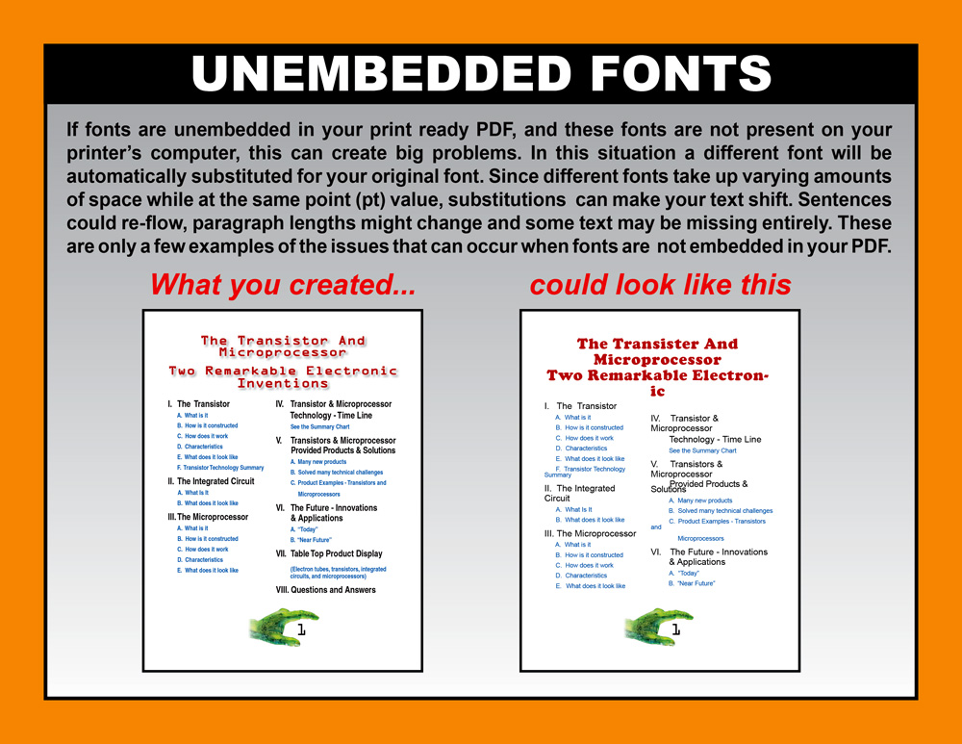

Embedding instructions for Windows users:

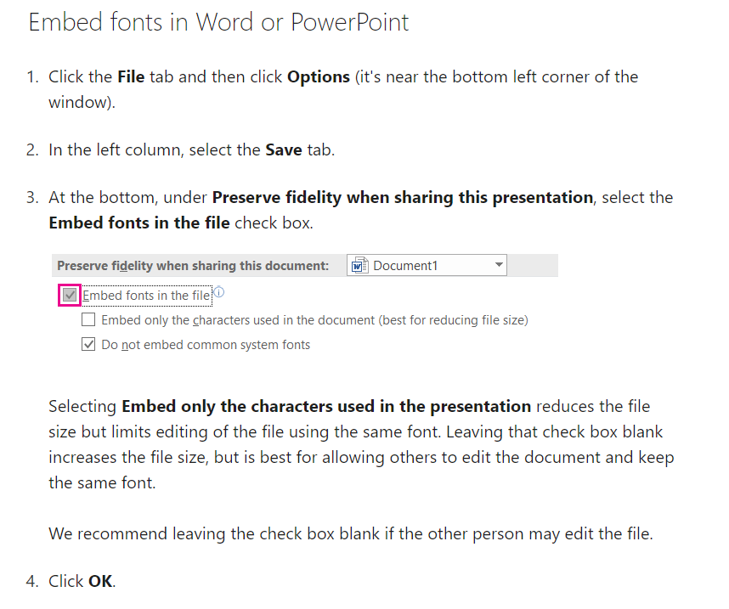

Embedding instructions for Mac users:

