WDI Assessment Overview: MAT202

For this assessment overview, a total of twenty-four (24) assignments were reviewed from 12 different students at different levels of achievement. Just as in the previous semester, in order to assess whether there was an improvement in student writing, two different assignments were reviewed for each student – the very first writing assignment that students submitted as well as their final portfolios, which gave the students the chance to improve their work based on their TA’s feedback. Students’ writing was assessed with respect to sentence completeness, grammatical correctness, clarity and ease of understanding, effective use of transitions and signposting, and overall appropriateness of language for writing relatively formally to second year students.

Each of the students whose assignments were reviewed demonstrated an improvement in at least two (2) of the writing criteria assessed by at least 0.5 point, with most students demonstrating improvement in three (3) or more categories. The most improvement was seen in the category of “Transition Expressions and Signposting” and the least improvement was observed in the category of “Language Level”, both of which are discussed in more detail below.

Complete Sentences

When comparing this term’s assignments with those from the previous term, there is a definite improvement in this category. Out of the twelve (12) students reviewed in the Fall, nine (9) showed an improvement by at least one level, whereas in this Winter term only seven (7) students did. Despite the lower number of students, this is a positive outcome as most students whose work was reviewed demonstrated the ability to write in full, complete sentences (see Figure 1), with eleven (11) out of twelve (12) students earning a minimum of 3 points on this category in their first assignment.
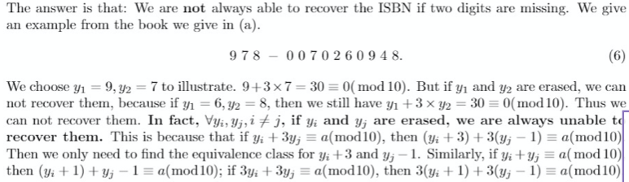

Figure 1 - Example of complete sentences (Booklet 8.1.)

Grammatical Correctness

Just as in the previous semester, this was one of the categories students struggled with the most in both versions of the assignments, perhaps due to a language barrier or limited practice in expressing mathematical thinking in a detailed, written format.

While the same three types of grammatical errors from the previous term (run-on sentences, improper verb conjugation, and incorrect use of plural form) were still seen and the discussion in my previous report still applies, this semester students also seem to have struggled with pronoun usage. In particular, students used pronouns ambiguously without introducing proper antecedents (see Figure 2). This resulted in an overall lack of sentence clarity, which is further discussed below.

Figure 2 - Ambiguous pronoun "it".

Sentence Clarity

Just like with the category of “Grammatical Correctness”, students also seemed to have faced some challenges regarding sentence clarity, which is again likely due to a language barrier or limited practice in expressing mathematical thinking in a detailed, written format. As before, I found myself having to read certain sentences more than once in order to understand what a student was trying to convey, which at times was still not possible (see Figure 3).

Figure 3 - Example of sentences lacking clarity.

As mentioned above, I believe that this lack of clarity also stemmed, in part, from grammatical errors made by students. Ambiguous pronouns, incorrect plural forms, run-on sentences, and improper verb conjugations resulted in sentences that severely lacked clarity. This correlation is particularly evident in the data as most students (11 out of 12) received the exact same mark for both categories in the two assignments reviewed.

Transition Expressions and Signposting

This was the category that students improved the most. Out of the twelve (12) students assessed, nine (9) showed an improvement of at least half a level in this category. However, this improvement may not be that significant since students had already done quite well in this category in the first assignment, with most using at least one transition expression to link their reasoning and show the logical relationship between their arguments.
Improvement in the final assignment came as a result of two factors: quantity and quality. In their final assignment, not only did students use more transition expressions, they also used more varied expressions, which improved overall writing quality by lessening repeating and increasing clarity and flow.

Language Level

Just as last term, I still believe while there is room for improvement, most students’ language is at an appropriate level for writing relatively formally to second year students. Out of the twelve (12) students reviewed, four (4) achieved the maximum level, six (6) achieved a level 3, and the remaining two students achieved a level of 2.5 in this category on their final portfolio. These numbers represent a decrease in improvement when compared to the results from last semester, as seven (7) out of the twelve (12) students did not show significant improvement after comparing their first and final assignments.

Additional Comments/Observations

Having reviewed the writing assignments in this and the previous semester, I cannot help it but to draw comparisons between both iterations of the assessment. It is my opinion that the level of quality of the assignments this semester is higher. In particular, last semester I mentioned that students’ explanations lacked justification and mathematical evidence. While this time the assignments are still not perfect, I definitely noticed a quantifiable improvement in this category. I am not sure if any changes were made in the presentation of the writing assignments to the students, but if this is the case then I would say this change had a positive outcome.

