WDI Assessment Overview: MAT133, writing proofs

For this assessment overview, a total of one hundred (100) assignments were reviewed from fifty (50) different students – ten (10) level A students, fifteen (15) level B students, fifteen (15) level C students, and ten (10) level D students. In order to assess whether there was an improvement in student writing, two different assignments were reviewed for each student – the very first writing assignment that students submitted as well as the very last one, which were administered six (6) months apart. Students’ writing was assessed with respect to sentence clarity and ease of understanding, response structure and logic, ambiguity of pronoun use, level of reasoning explanation, and use of definitions. The feedback given by peers and by Tas was also reviewed and evaluated for appropriateness.

The majority of students whose assignments were reviewed (44 to be precise) demonstrated an improvement in at least one of the writing criteria assessed, with thirty-eight (38) students demonstrating improvement in two (2) or more categories by at least 0.5 point. And while 6 students did achieve a negative score when comparing their work in WA1 to their work in WA4, this is likely due to “end-of-semester fatigue”. In my opinion, these results are indicative that students do benefit from the writing assignments in this course and that their writing does seem to improve with each iteration of a writing assignment.

Clear Sentences:

While most students presented work that was neat and clearly legible, they seemed to have faced some challenges when it came to sentence clarity, which is likely due to a language barrier or limited practice in expressing mathematical thinking in a detailed, written format. I found myself having to read certain sentences three or four times before I was able to understand what a student was trying to convey.

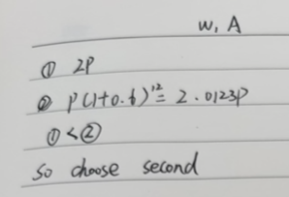
As I had mentioned in a previous report, the issue of lack of clarity may stem in part from a lack of detail as well. Perhaps because students did not quite know what a writing assignment consisted of or what was expected of them, a lot of students simply presented their mathematical reasoning without offering much discussion in WA1 (see Figure 1). This lack of detail in conjunction with poor grammar does lead to a lack of sentence clarity. This issue was greatly improved in WA4, with most students presenting work that was much clearer and easier to follow.
Figure 1 – One student’s full solution for WA1 showing a severe lack of detail.

Logical and Well-Structured Response:

In my opinion, a proper writing assignment should include three components: an introduction where the student outlines the problem and how they will approach it – at this stage students should define variables and introduce formulas/theorems that they will use; the solution, where the students work out the mathematical process for solving the problem, making use of the variables, formulas/theorems previously defined and explaining each step of the process in detail; and finally, the conclusion, where students clearly restate their final answer and explain its meaning or significance.

I would say that this was one of the categories students struggled with the most as while most students knew which algebraic steps to take in order to solve the problem, they did not have a complete setup for a writing assignment, often jumping straight into the solution without giving the reader an explanation of what they were doing and why they were doing it (again, see Figure 1). As before, I did see an improvement in this category in WA4; however, I do think that there is more room for improvement.

Unambiguous Pronouns:

Students did quite well in this category. Reading through the different writing assignments, I could tell what each pronoun referred to and did not really ever find myself lost in this aspect. However, quite a few students used demonstrative and personal pronouns in excess, which even though not ambiguous still takes away from the quality of the writing assignment (see Figure 2).
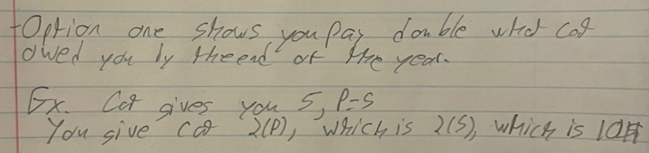
Figure 2 - Excessive use of pronouns in one student's WA1.

Explain Why, Not Just What:
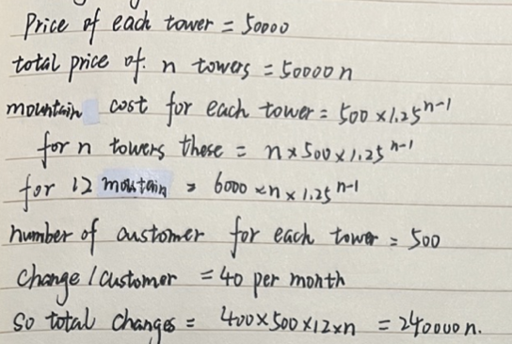
Students struggled quite a lot in this category, especially in the first writing assignment (WA1), which is once again likely due to the uncertainty of expectations and lack of practice with this type of assessment. As it can be seen in Figure 3, most students did not provide much of an explanation about what they were doing and even less about why they were doing it.
I did see an improvement in WA4, with many students providing full sentences explaining what they were doing; still, not many students explained why they used the techniques/concepts they did. It is my understanding that students are told to explain their solutions as if their reader does not have a background in mathematics – I would say this largely not reflected in the assignments. As such, I believe this is certainly a part of the writing assignments that might have to be further explained and perhaps modelled in future years.

Use of Definitions:

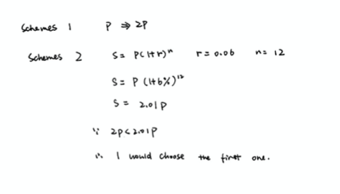
Similarly to the category “Explain Why, Not Just What” above, students also seem to have found the category of “Use of Definitions” fairly challenging. In both iterations of the writing assignment, most students successfully used the appropriate formulas and concepts; however, they did not successfully introduce or fully define them. This issue is illustrated in Figure 3, where a student’s solution to WA1 is shown. In this solution, the student used the correct formula,
S = P(1 + r)^{n}, but they do not explain what this formula is, what it is used for, or even define the variables. This was the general trend among most assignments.
Figure 3 - One student's solution for WA1, where the lack of definitions is particularly apparent.

Appropriate Issues in Feedback:

- Peer Feedback:

This was one of the categories where I saw the most variation in both quantity and quality of work. Some students left one sentence of feedback to their partner, while others left pages. Some students were able to accurately and thoroughly detail the strengths and weaknesses of their partner’s work, while others focused on issues that were not very relevant. In particular, a lot of students focused on the fact that their partner did not include a diagram in their solution or had not solved the question in multiple ways. Both of these criteria were present in the feedback diagram; however, students did not seem to be able to understand that depending on the question, these items did not make up meaningful feedback. Even though diagrams and multiple solutions can certainly strengthen an assignment, they are not always possible depending on the question given. One suggestion is to perhaps remove these two criteria points from the feedback diagram so that students do not focus so heavily on them and are able to give more meaningful
feedback to their partners.
- TA Feedback:
After reviewing all one hundred assignments, the first issue I noticed was that TA feedback should be more consistent. Similarly to student feedback, TA feedback also varied greatly depending on which TA had marked the assignment. One issue that I did find was that the feedback left by the TAs could have been more thorough. I know that TAs have limited time to mark; however, students rely on feedback to improve their work and if this feedback is practically non-existent, then improvement is going to be more difficult to achieve. This issue was particularly noticeable with one TA who mostly left quantitative feedback instead of qualitative feedback (see Figure 4).

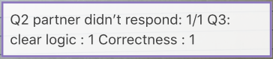

Figure 4 - Example of insufficient TA feedback.

In the future, I think it would be helpful to try and have the same group of TAs mark all of the writing assignments as well as provide them with some training (in the form of a benchmarking session perhaps) before the marking of the first writing assignment to ensure that TAs know exactly what is expected of their marking.

Additional Comments/Observations:

A lot of students simply resubmitted their first draft of the writing assignment as their last draft. Doing this, goes against the whole purpose of the assignment that asks students to redo their work based on peer feedback and self-reflection. Since this reviewing process is such an important part of the writing process, perhaps students need some sort of incentive (in the form of marks perhaps) to “force” them to actually go through the re-writing process.

